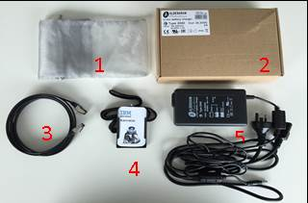**In the Box:**

1. Grey bag for networking cable and I.D. badge
2. Storage box for power cables
3. Networking cable
4. NAO’S I.D. Badge
5. 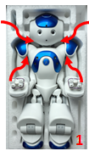Power cable

**Starting Checklist:**

1. When taking NAO out of the box, gently lift NAO from under each arm and above each shoulder, lifting the torso and head out first, followed by the legs   
   **NB: Support NAO’s head when lifting him out of the box**
2. Lay NAO on his back on a flat and stable surface **at least 60cm from any edges**
3. 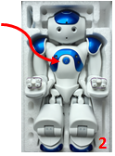Remove elastic bands from each hand placing them back in the polystyrene box
4. To turn NAO on, press and release the chest button
   1. Wait 3-5minutes for NAO to boot up
   2. NAO will say “**GNOUK GNOUK”**
   3. NAO will then automatically stand up

**Connectivity:**

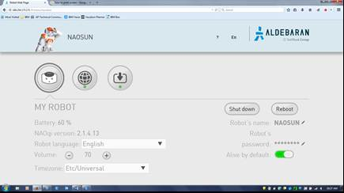Connecting NAO to *Web Remote* enables you to adjust volume, language and network settings.

**Do not attempt to launch *Web Remote* until NAO is turned on and standing.**

1. Push and then release NAO’s chest button to hear NAO’s current IP address
   1. If you attempt this step 3 times, NAO will repeat the IP address very slowly in order for the user to hear it clearly
2. **Note:** Unless the NAO is configured to automatically connect to an available Wi-Fi network, it will have no IP address. In this case, it will utter “I cannot connect to the network”. In this case, connect to the NAO using the Ethernet cable (located in the back of its head). Wait a few seconds and press the chest button again to hear the IP address.
3. Type the given IP address into URL. Make a note of the IP address as it will be used later on
4. Username and Password: nao

**NB** NAO’s IP address *will* change, hence repeat process until connection is established

**Troubleshooting:** If connection continues to time out, connect NAO to your computer via the networking cable. (See ‘Using Choregraphe’; steps 2 and 3). NAO will then automatically change the IP address (may take 1-2 minutes). After the IP address changes, the user should restart the Connectivity Process.

**Indicators and References:**

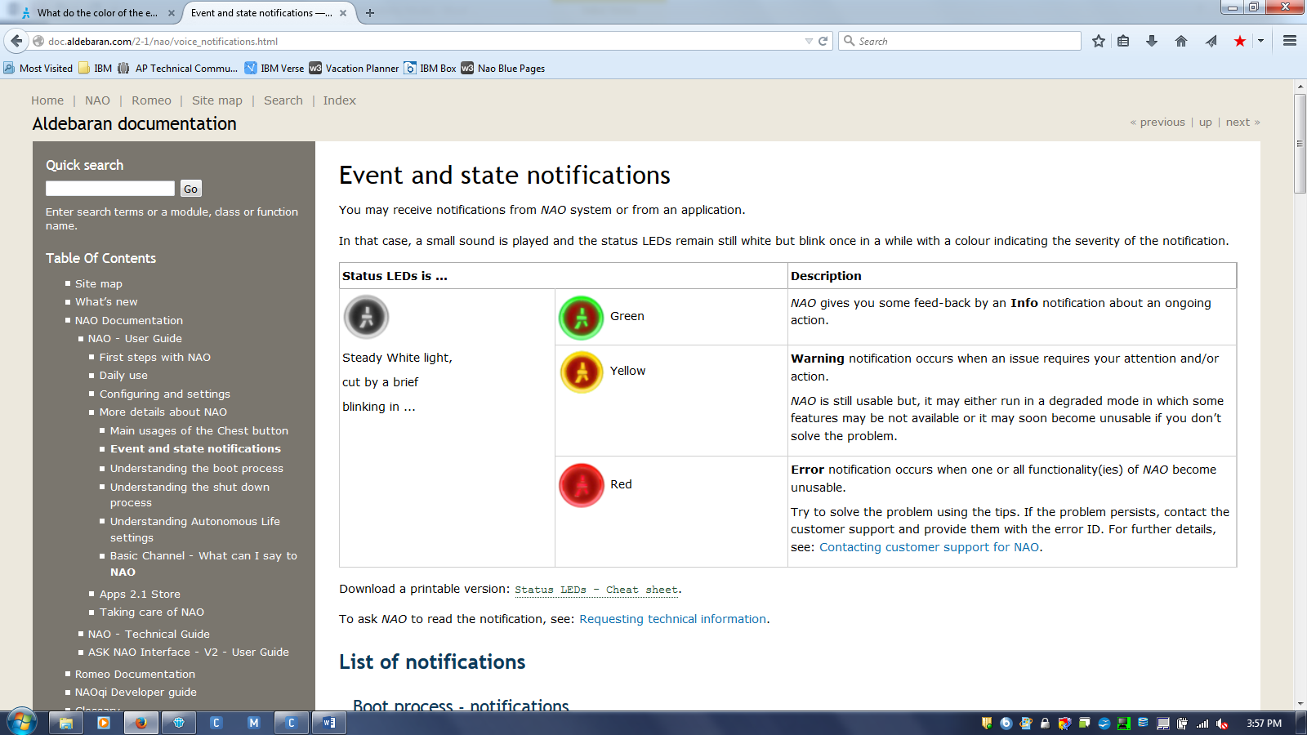

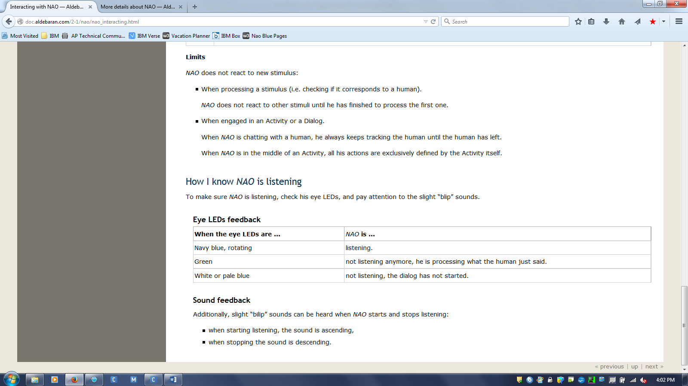

NAO Documentation: <http://doc.aldebaran.com/2-1/home_nao.html>

Choregraphe user guide: <http://doc.aldebaran.com/1-14/software/choregraphe/index.html>

NAO Blue Pages: <https://w3-03.sso.ibm.com/bluepages/searchByName.wss?uid=AVJSRC616&task=viewrecord>

**Joining the Developer Community and Installing Choregraphe:**Choregraphe is Aldebaran’s graphical programming interface which allows users to program simulations for NAO. This software enables you to generate demonstrations for presentations, scripting movements and dialogue.   
 **NB:** If Choregraphe is installed, skip to ‘Using Choregraphe’

1. Go to Aldebaran Website: [www.aldebaran.com/en](http://www.aldebaran.com/en)  
     
   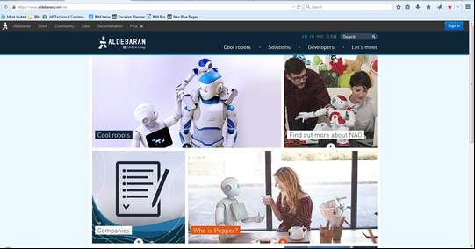
2. 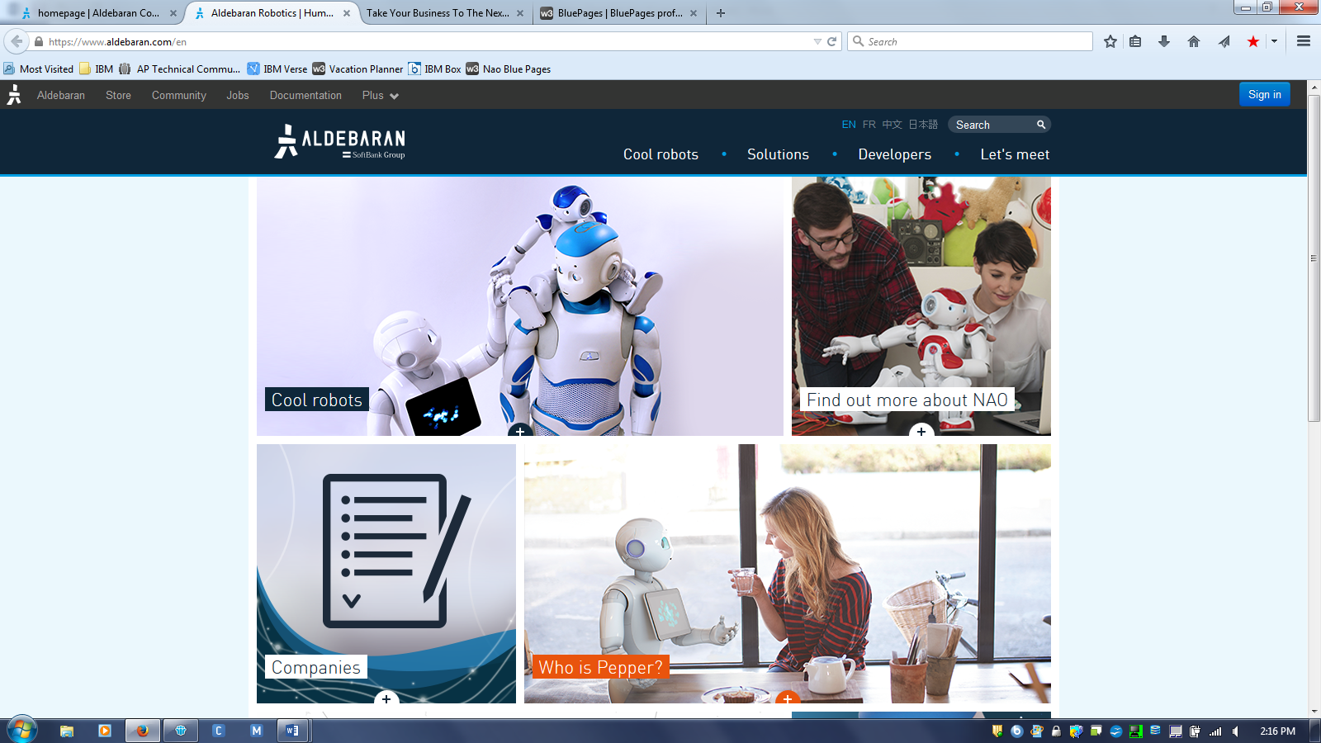Click Community
3. 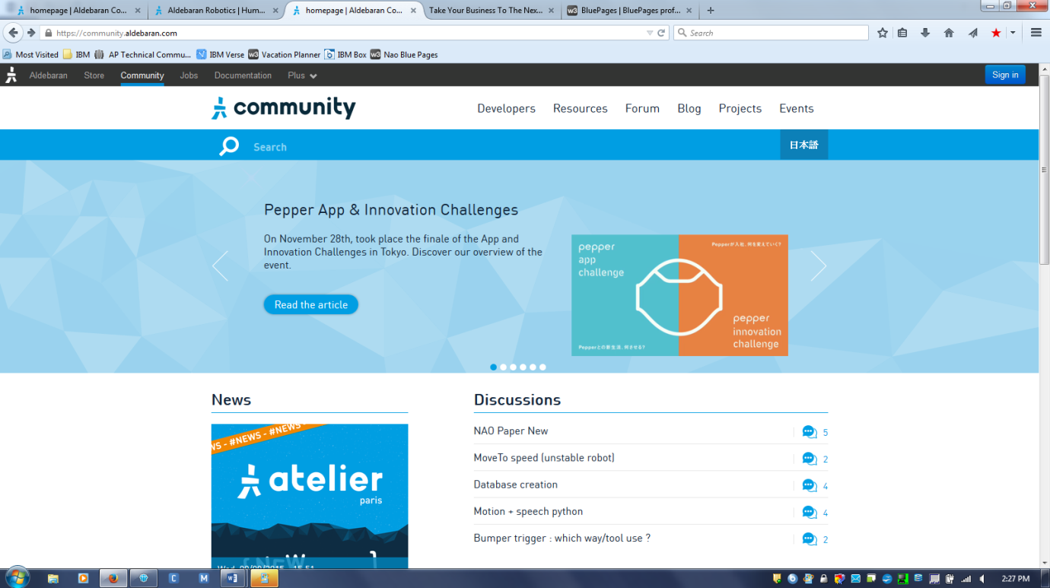Click Developers
4. Click Join



1. Click sign in and follow the prompts to register an account
   1. Country: America
   2. Use: Professional
2. Once registered, click Community



1. Click Developers

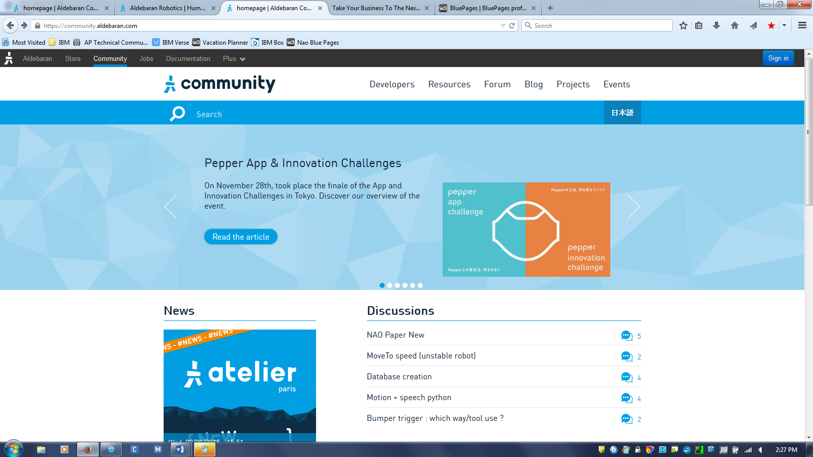

1. Scroll down until you see the following, then click the Choregraphe link

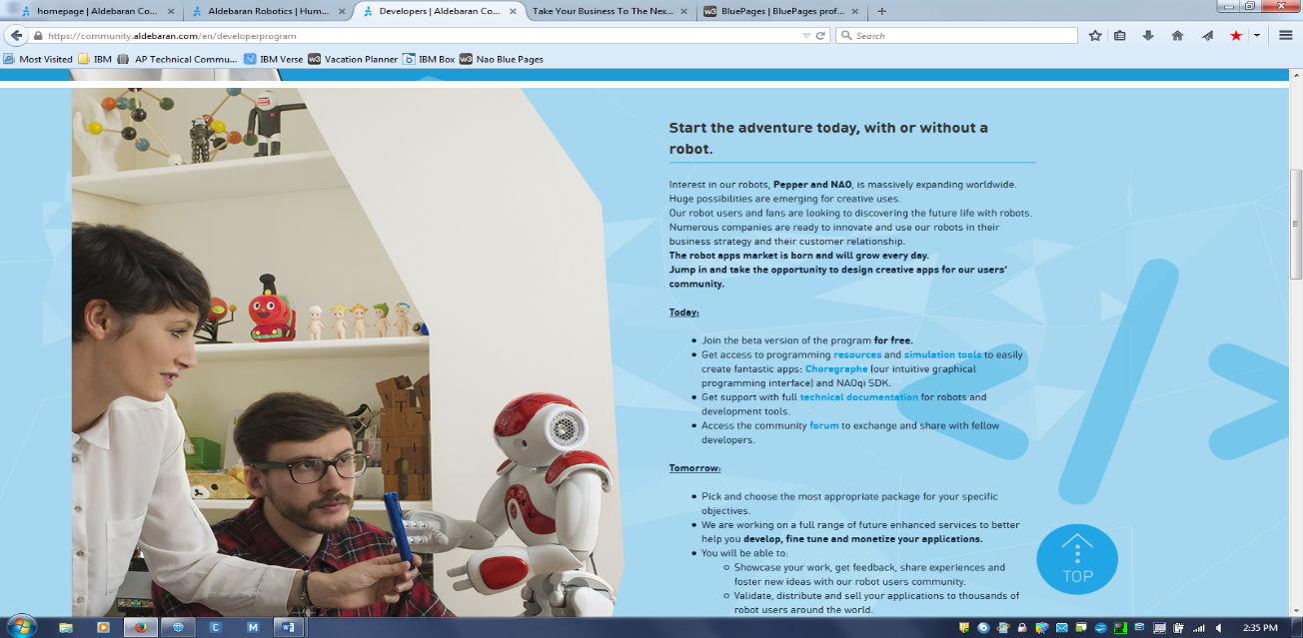

1. Click your applicable Operating System (OS) and download the ‘Setup’ file

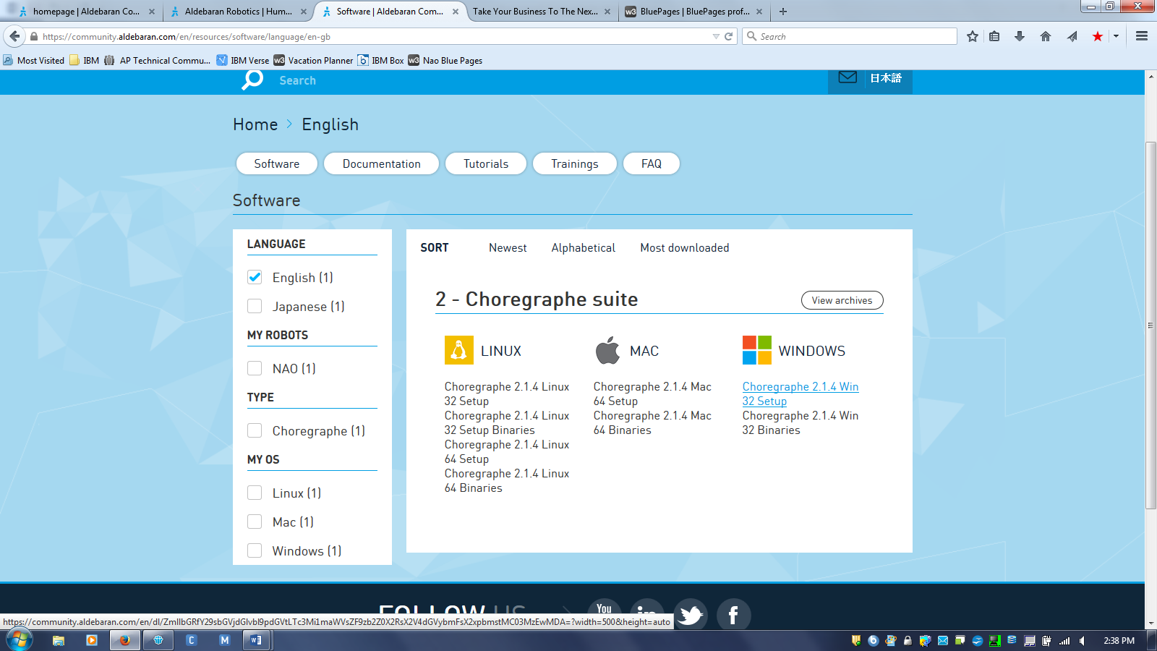

1. Save File

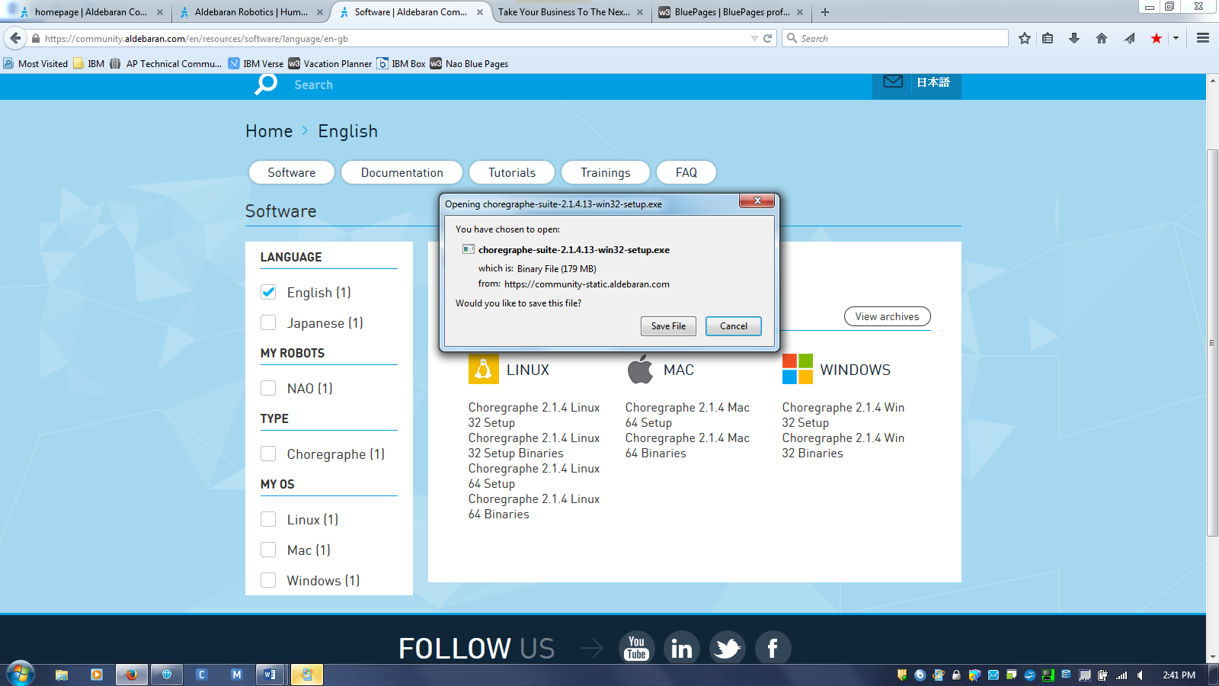

1. Open the downloaded file which will be located in your ‘Downloads’ folder
2. Follow the installation prompts
3. After agreeing to terms and conditions, select the ‘90 day free trial option’ below ‘License key’ or enter your licence key if you have one.
4. Open and run Choregraphe, selecting ‘Free Trial’ when prompted as below:

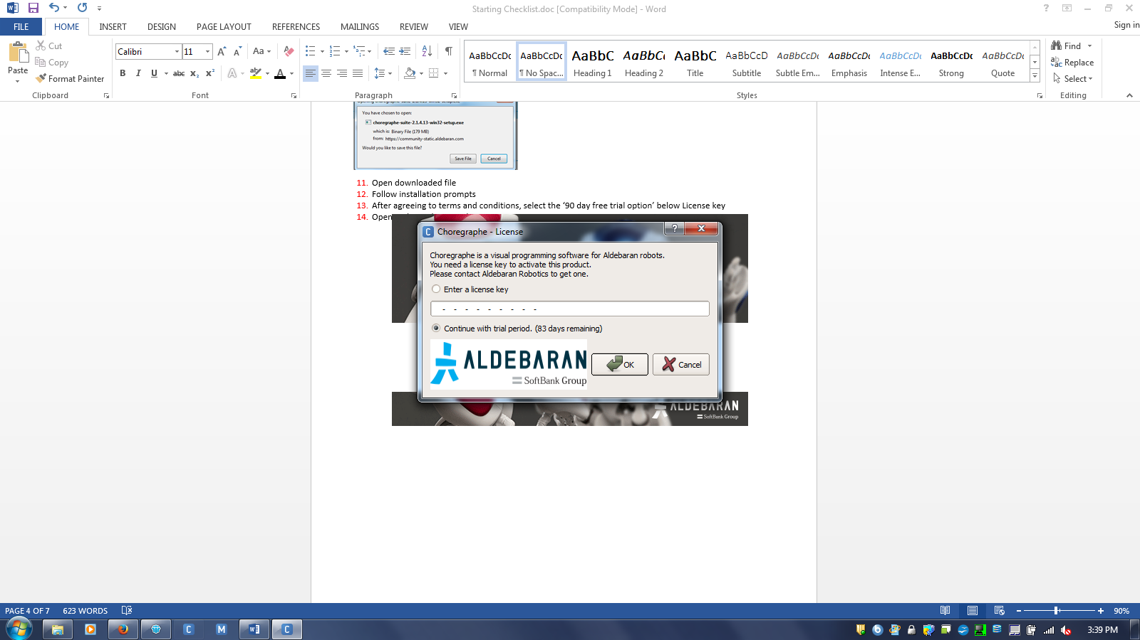

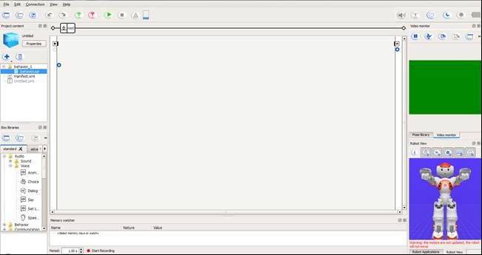

**Using Choregraphe:**

*Do not attempt to connect NAO to Choregraphe until Web Remote connection has been established (See ‘Connectivity’ for instructions)*

1. If you have not done so already, launch Choregraphe
2. Remove blue cover from the back of NAO’s head in order to connect Networking cord
3. Connect the Networking cord to NAO *and* your computer   
   **NB: Do not lay NAO on his back when networking cable is connected**

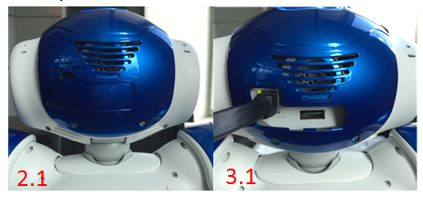

1. Click the following button to connect to NAO

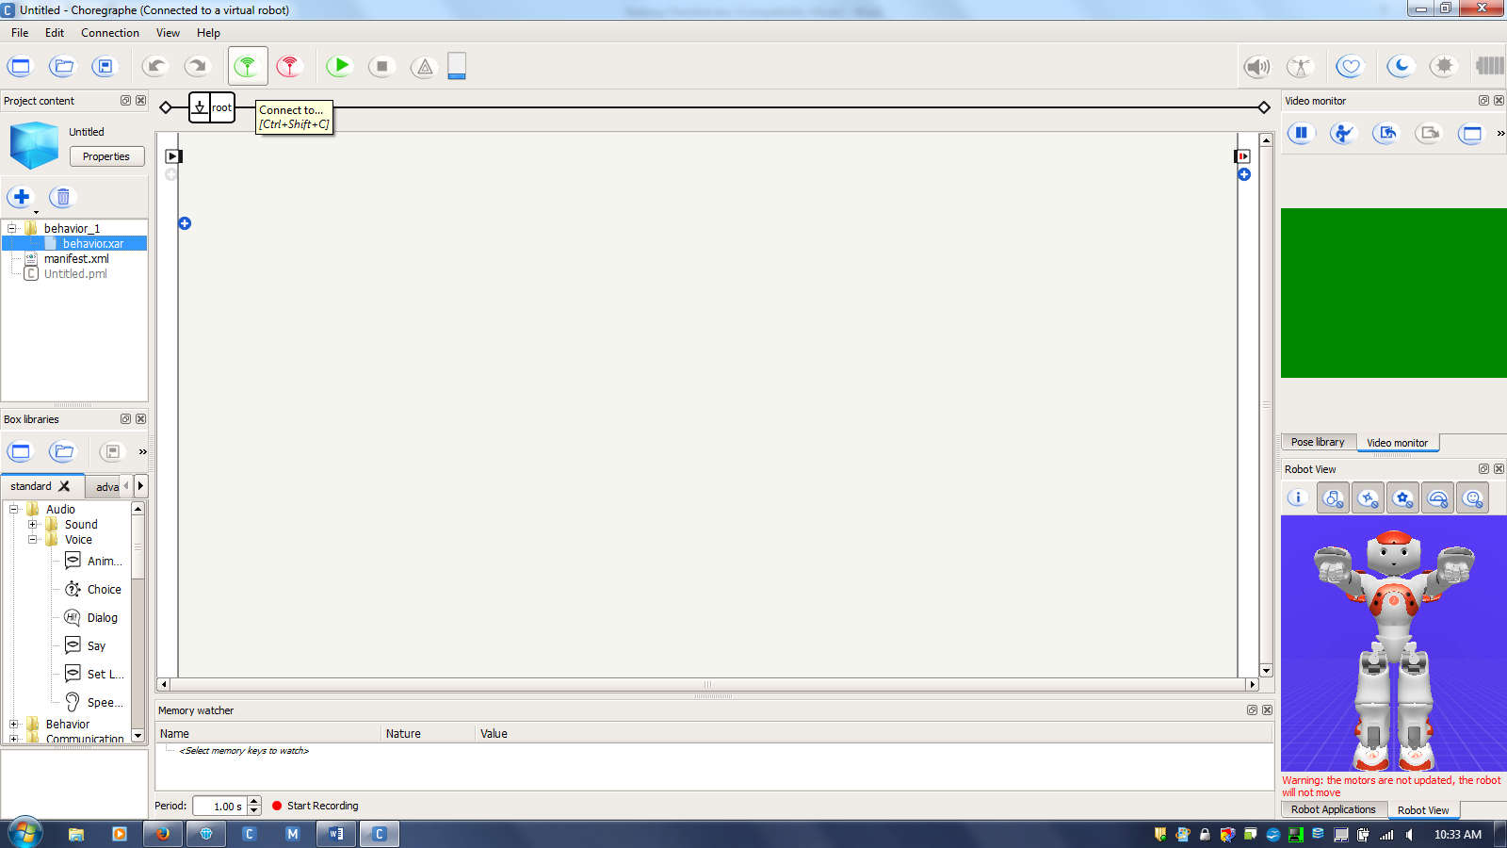

When using Choregraphe, you must connect to either NAO or Virtual Nao  
Virtual Nao enables the user to use Choregraphe when NAO is not connected to your computer (i.e. when you do not have NAO at your disposal). Simulation functionality is limited when using Virtual Nao as the camera and speech recognition tools require NAO to be connected to Choregraphe.

1. 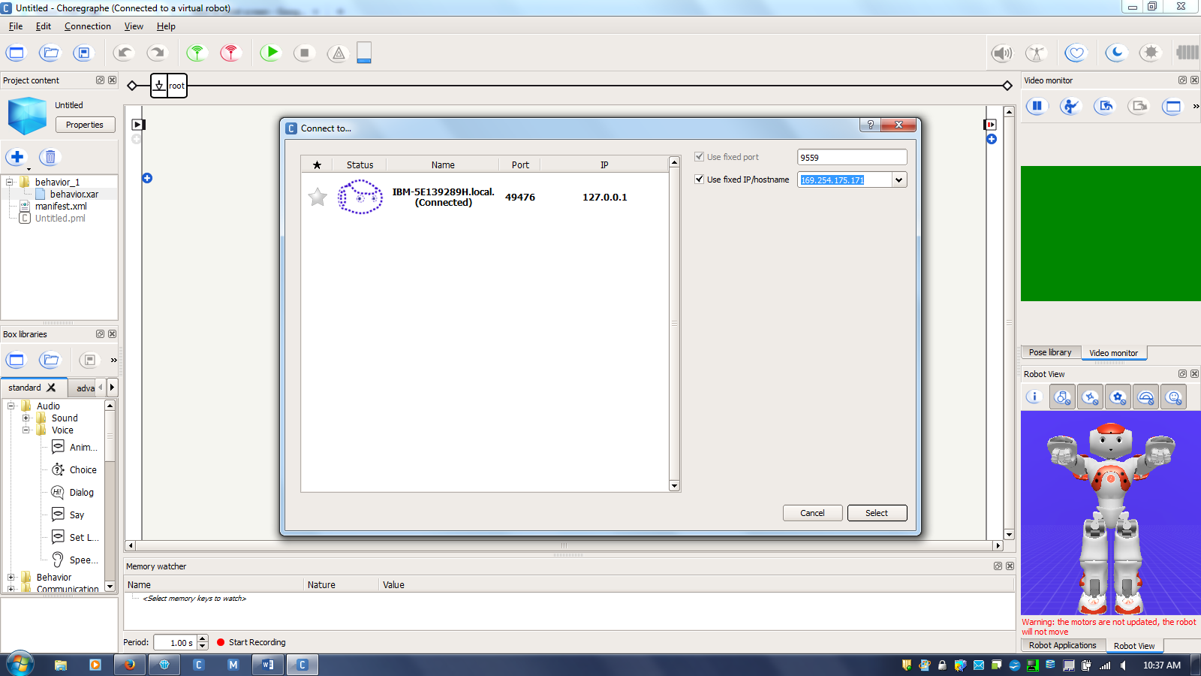The following connection represents ‘Virtual Nao’  
     
     
     
   1. ***Windows OS ONLY:*** Before attempting a connection with NAO, you must disable Symantec Endpoint Protection. You can do this by right-clicking it on your taskbar and selecting ‘Disable Symantec Endpoint Protection’. Disabling Symantec will shut down your device after 15 minutes. In order to prevent this, repeat this step every 15minutes when Symantec announces shutdown.

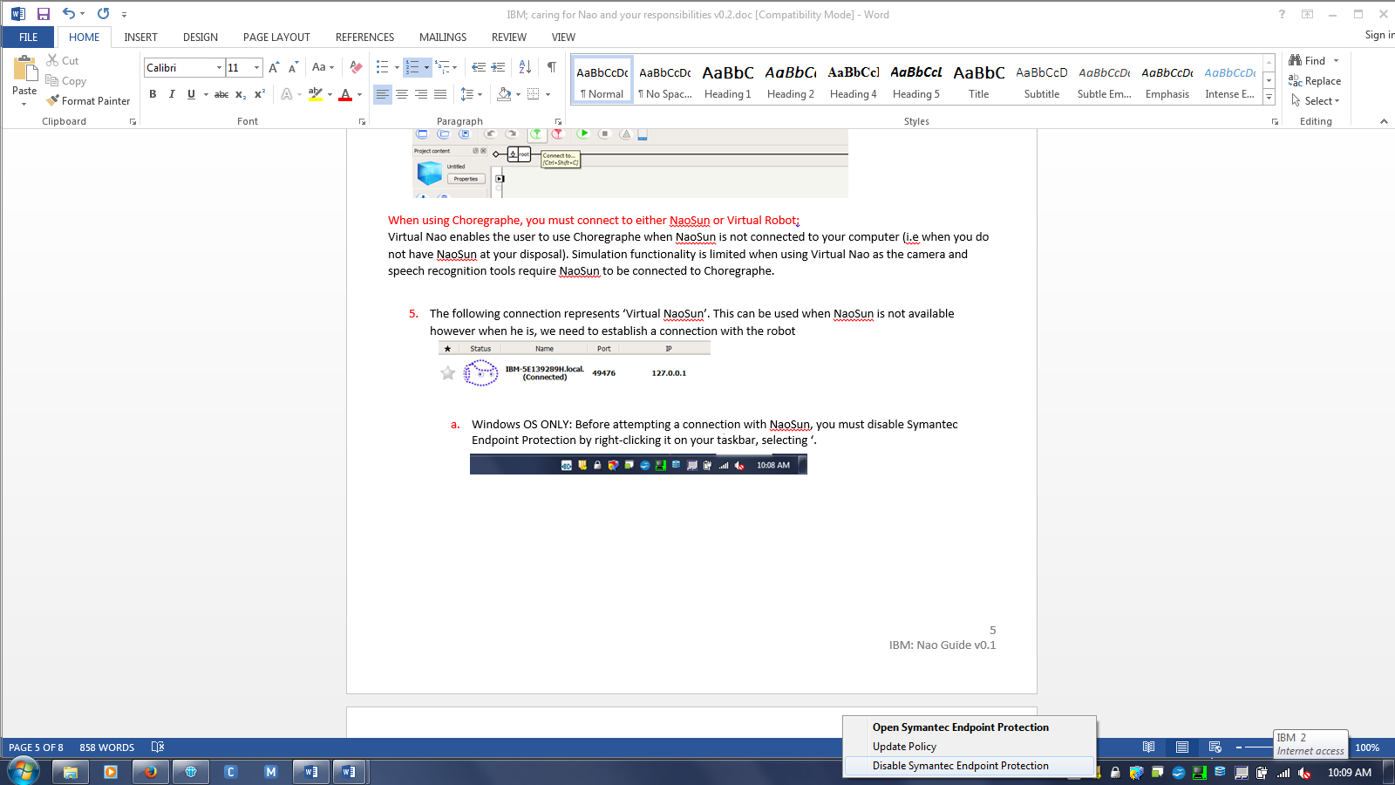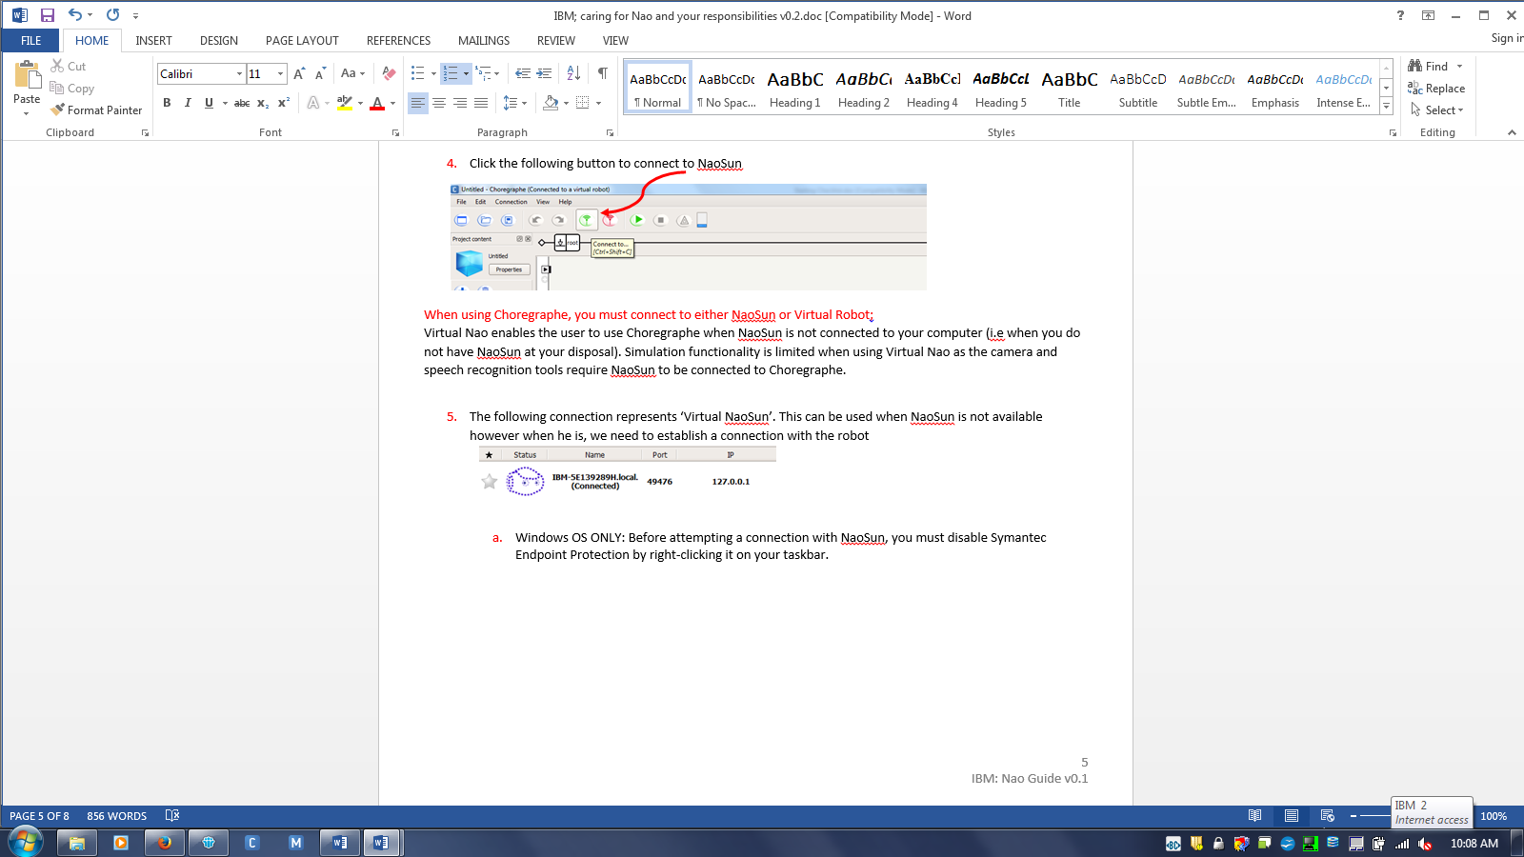

* 1. Type NAO’s IP Address in the following box and ensure both boxes have been ticked  
     Once entered click “select”  
     *NB: Use IP address given to you in ‘Connectivity’*

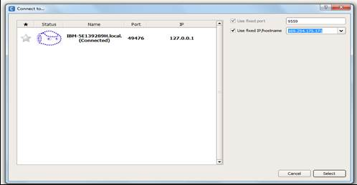

**Troubleshooting:** If connection is not established, please close Choregraphe and double check NAO’s IP address by pressing and releasing NAO’s chest button. Retry step 5b.

1. Once connection has been established, click ‘Video Monitor’ to see NAO’s camera feed  
   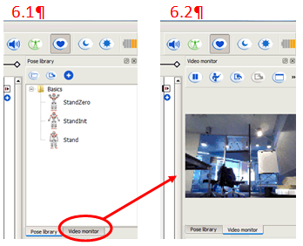

**You are now ready to use Choregraphe**

1. When you have finished using Choregraphe, please disconnect NAO *before* closing the program.
   1. Click ‘Disconnect’ button to terminate connection to NAO.

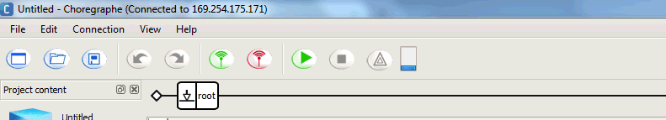

**Closing Checklist:**

**NB: NAO should ONLY be transported in the Pelican Case**

1. Remove Networking Cable and put plastic cover on the back of the head
2. Tell NAO to “shut down” then reply “yes” to his shutdown question (only if you have basic channel installed). If NAO does not shut down, press and hold the chest button for 3 seconds

**NB:** LED’s will begin to turn off. If standing, NAO will crouch, if sitting, NAO will remain sitting

1. There is a short cooling off period (30 seconds) in which NAO completes the shutdown process
2. Shut Down is complete when the chest LED is off
3. Let NAO cool down for 5 minutes
4. Complete ‘Inventory Checklist Form’ to ensure all components are accounted for
5. When putting NAO back into the box, place head, arms and torso in *first,* ensuring fingers are curled into a fist with elastic bands wrapped around as shown below:  
   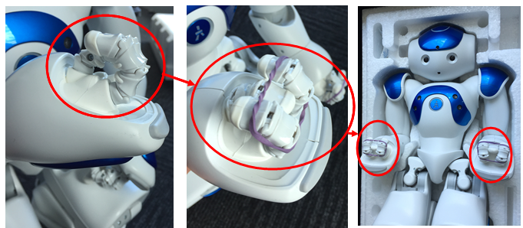
6. Bend legs individually until the tip of the feet touch the knees, placing them inside their respective slots  
   **NB:** Ensure the feet are pushed up to the edge of the box  
     
   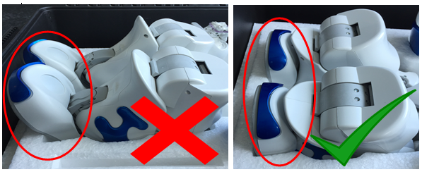
7. Place the power cable in the cardboard box and place the networking cable and NAO’s badge inside the grey bag

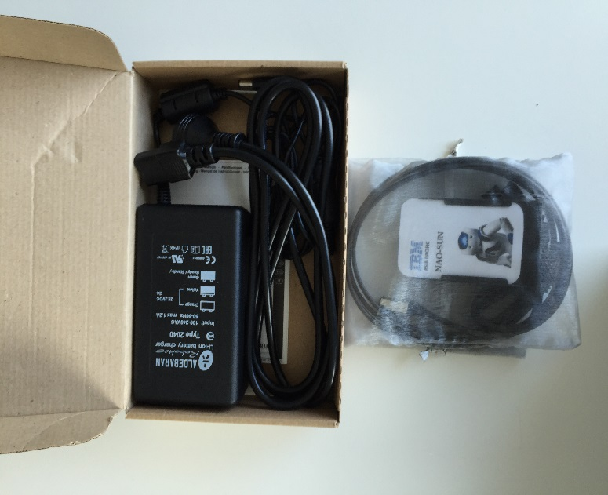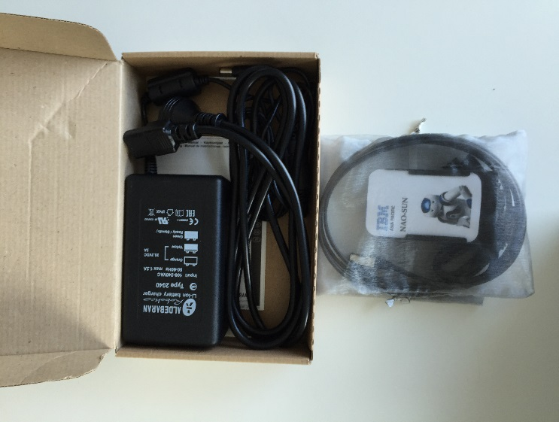

1. 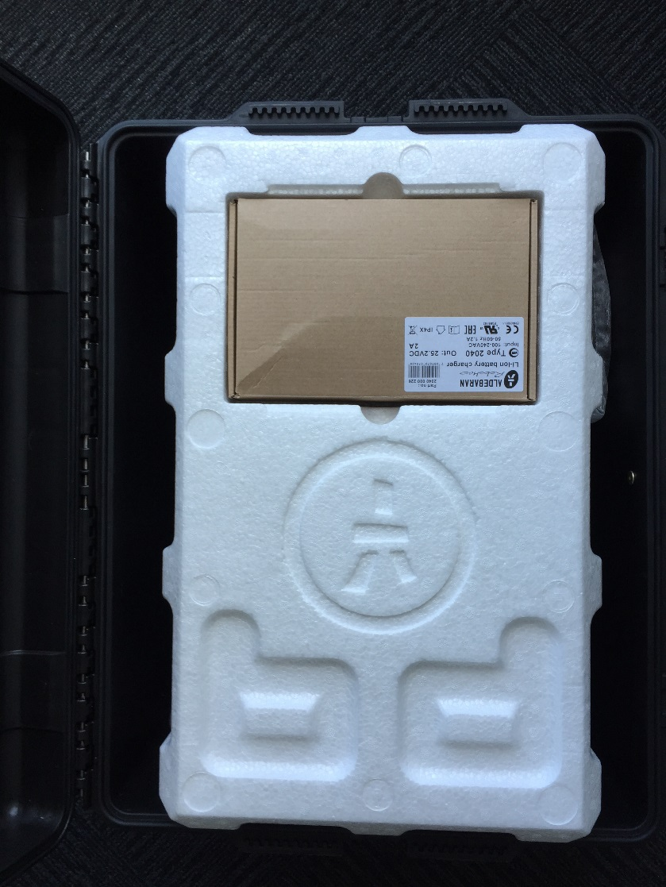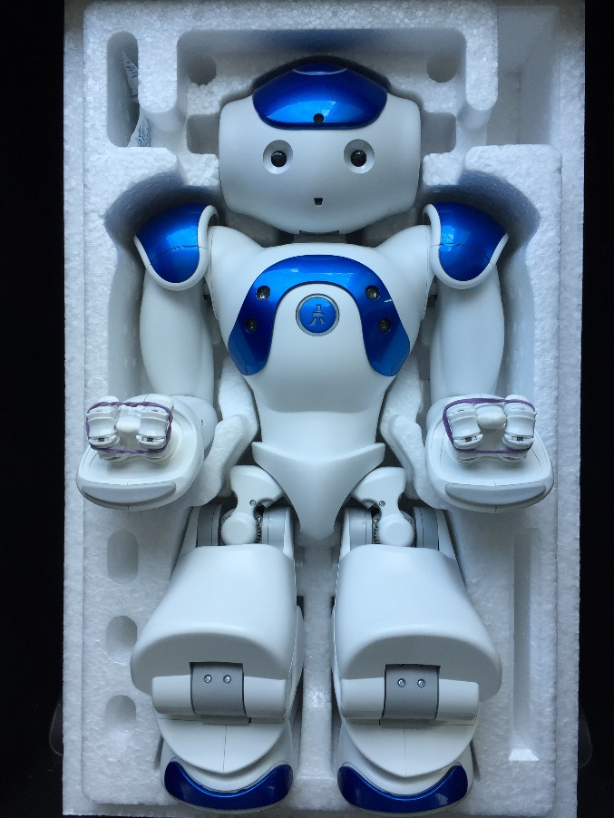Place the cardboard box in the cut-out slot and place the grey bag on the side of the polystyrene box
2. Gently place the polystyrene lid on top of NAO, DO NOT FORCE DOWN.

**NB:** If the lid *does not* fit properly, double check NAO is laying correctly in the polystyrene box, then retry

1. Close the Pelican Case, ensuring all clips are locked down